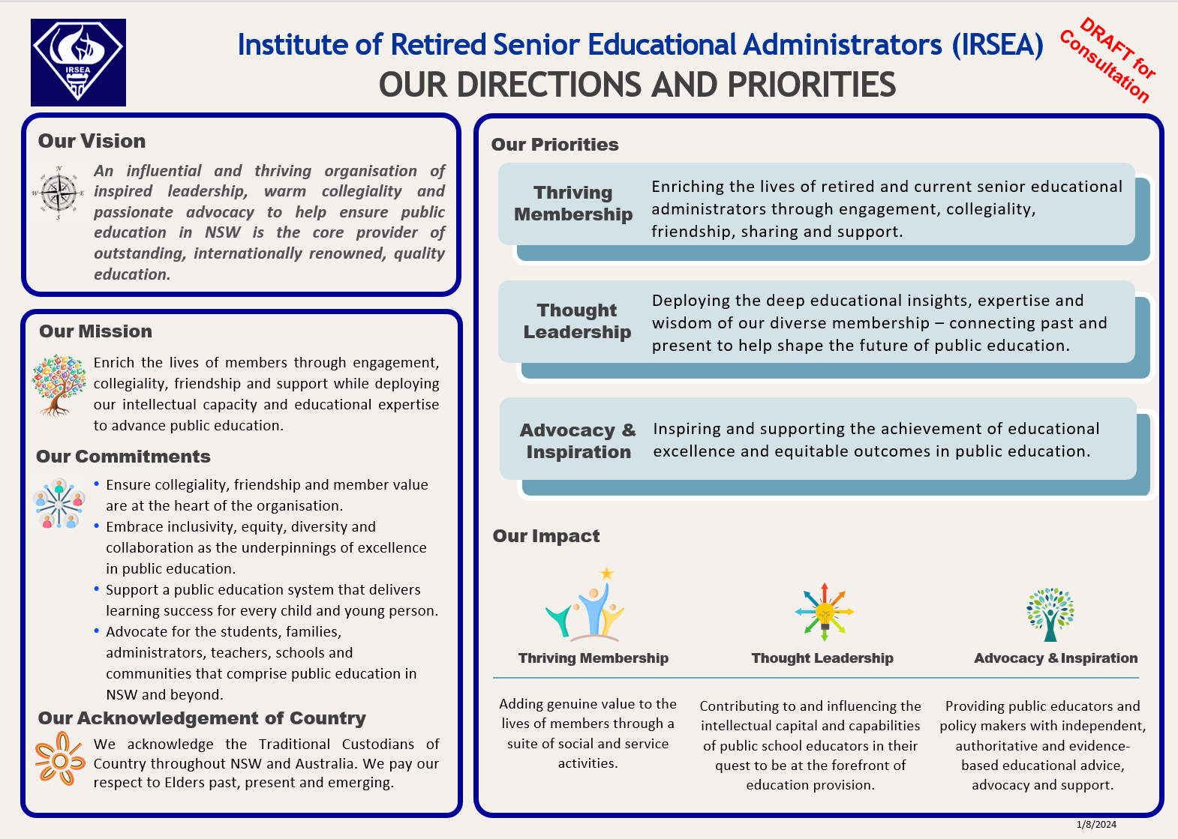

IRSEA PLAN: CONSTITUTIONAL CONTEXT
Extract of Mission and Objects from the IRSEA Constitution
2 Mission Statement and Objects
2.1 IRSEA enriches the lives of retired Senior Educational Administrators through engagement, collegiality, friendship and support while deploying its intellectual capacity and educational expertise to advance public education in New South Wales.
2.2 The Objects of the Institute are to:
(a) preserve friendship and a sense of identity among those senior men and women who have spent their professional endeavours in the field of public education
(b) provide whatever donations and other support to Stewart House, Harbord, New South Wales, or any other non-profit tax-exempt charitable organisation for children, as may be determined at each Annual General Meeting of the Institute
(c) provide members with a forum for the discussion of educational issues
(d) offer the benefits of the members’ experience and wisdom to policy makers and senior officers in public education and to the wider community
(e) provide support that may enhance the welfare and quality of life of members in regard to retirement matters
(f) contribute to the body of knowledge about the evolution of public education in New South Wales, Australia.

SURVEY
BACKGROUND
Your name (optional):
1. Please indicate your membership status:
☐ Full ☐ Associate ☐ Honorary ☐ Life
2. Approximately how many years have you been an IRSEA member: _____________
FEEDBACK:
3. To what extent does the one-page plan clearly reflect and communicate the constitutional objectives of IRSEA?
☐ To a great extent ☐ To some extent ☐ To a minimal extent ☐ Not at all
Comment?
4. To what extent do you agree with the following IRSEA statements:
Vision: ☐Strongly agree ☐Agree ☐Neutral ☐Disagree ☐Strongly disagree
Mission: ☐Strongly agree ☐Agree ☐Neutral ☐Disagree ☐Strongly disagree
Commitments: ☐Strongly agree ☐Agree ☐Neutral ☐Disagree ☐Strongly disagree
Priorities: ☐Strongly agree ☐Agree ☐Neutral ☐Disagree ☐Strongly disagree
Impacts: ☐Strongly agree ☐Agree ☐Neutral ☐Disagree ☐Strongly disagree
Comment?
5a Is the plan feasible? ☐Strongly agree ☐Agree ☐Neutral ☐Disagree ☐Strongly disagree
5b Is the plan achievable?☐Strongly agree ☐Agree ☐Neutral ☐Disagree ☐Strongly disagree
Comment?
6. Please share any suggested improvements or changes you would like to make to the wording or intent of the plan.
7. To what extent can the plan guide IRSEA to have significant positive impact for its members and for public education in the future?
IRSEA Members: ☐Greatly impact ☐Moderately impact ☐Some impact ☐No impact
Public Education: ☐Greatly impact ☐Moderately impact ☐Some impact ☐No impact
8. Is there any comment you would like to add about the potential impact of the plan?
9. Please add any further feedback you have regarding the plan?

PLEASE EMAIL YOUR SURVEY RESPONSE TO secretary@irsea.org.au

